Final Project

Design Document

By Corin St. Ours for CSC221 Final Project

Introduction 2

Project Functionality 2

Design Process 2

Project Development 2

Pseudocode 2

Flowchart 2

UML Diagram 2

Requirements 2

## Introduction

### Project Functionality

There will be 4 basic directions of movement, up, down, left, right. It will be projected onto the screen as a separate window and the player can choose when to start playing by clicking a start button. The objective will be to collect “fruit” in the shape of red squares/circles. There will be a scoreboard tracking how many fruit you have collected at a 1:1 rate. Each time the snake eats a fruit the snake will grow by 1 square and another fruit will spawn randomly. The game ends when the snake runs into itself or into a wall, and the start game screen will appear again.

### Design Process

Here is where you will talk about how you created your final project. This should include the reasoning behind the design decisions previously discussed (they `why` of your designs). Additionally, include any hiccups/issues, parts that went well, and parts you enjoyed in making your final project.

## Project Development

### Pseudocode

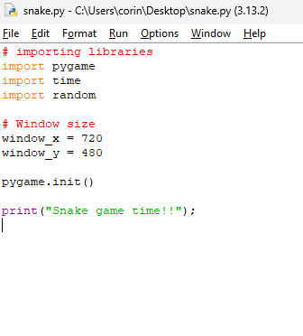

### Flowchart

This is for your flowchart***.*** Please provide the design you based your algorithm on in the form of a flowchart as discussed in the course.

### UML Diagram

This is for your UML diagram***.*** Please provide your UML diagram (if you need to create one).

### Requirements

This is for keeping track of the requirements you fulfilled during the final project***.*** Please discuss each of the objectives/requirements listed in the final project assignment and how your final project meets/exceeds them.